Grade 7 Accelerated · Unit 3 · Lesson 9  Writing Small Numbers in Scientific Notation  Independent Set 3.09 | Name______________________  Date______________________  Period____________________

Six questions, on your own, in silence. Show the step that does the work.
1. Write 0.00047 in scientific notation.

2. Write 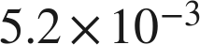 in standard form.

3. Write 0.0000061 in scientific notation.

4. Which is greater, 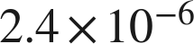 or 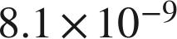 ?

5. How many times larger is 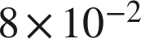 than 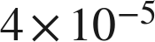 ?

6. A computer displays a number as 3.7E−5. Write it in standard form.

